


LAB5 : Static routing

Network

Table des matières
1.Goals 2
2.Internet access 2
3.Static route between LAN via LINUX 3
4.The field « time to live » 3
5.Synthesis 4


By Rexy

Goals
This practical work is about static routing between LAN.
- Documents : ip-arp-icmp.pdf (LAB3)
- Notions mentioned : broadcast domains, static routing, default routing, TTL fields
- Commands and useful files : route, tracepath, lynx
- Work to make : You have to answer to several questions directly on this sheet. You will copy this document on the Moodle under the name : « LAB5_your_names.odt ».

Internet access
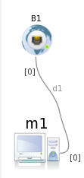
Marionnet offers way to be connected with the host machine (so with Internet). This exit point, named a bridge, allows to be connected on the host's card eth0. For the devices which are inside the simulator, this exit point acts as a DHCP server and as an exit router.
Connection of the simulator to Internet
- Define an easy architecture with a guest machine M1 which is connected to a bridge B1. Configure the IP address of M1 dynamically. From the DHCP information got by M1, define the addressing plan established by the DHCP server which is inside B1 and find the IP address of the router for Internet access (B1).
- Check if M1 can access to Internet using the WEB text navigator « lynx ».
Show a screen shot of M1 (lynx)

With Linux, the command « route » allows you to manipulate the routing table (to display and to modify)
Display the routing table of M1.

How did you analyze this lines ?

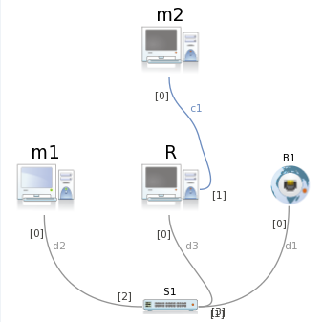
- From this basic infrastructure, add a switch S1 and a machine R which will be use as a router to the new private LAN which contains a machine M2. Configure the network card of R linked to S1 statically. Check that M1 can still access to Internet and can discuss with the R's card presents on its LAN.
- Define a address plan for the LAN with M2 and the second card of R, Configure them statically. Check the communication between the both.
Why M2 can't speak with M1 ?

Static route between LAN via LINUX
A network device can send directly IP packet to the other devices located in the same network address. If he wants to send a IP packet to a device which is outside of the network (in another LAN), he musts go through a router which knows this other network or at least how to reach this network. Static routing consists to give to a device the router's address he needs to use to reach another LAN.
Display and analyze the Tables of M1,M2 and R. Which route do you need to add to M1 to communicate with M2 ? Will M2 be able to answer ?

Add the routes needed. Test the connectivity between M1 and the network card of R which is in the same LAN as M2. Try as well the connectivity between M2 and the other network card of R.
If you try the communication between M1 and M2, you will notice it does not work. In fact, Linux kernel of R is not configure to transfer packets from one LAN to another.
Find and modify the parameter inside R's kernel which allows transfer of packets between the both network interfaces (mode router). Test the connectivity between M1 and M2.
Kernel parameters :

Analyze a frame received by M1 from M2. Which is the device corresponding to the source MAC address ? Do the same analyze with a frame in M2 from M1.

Analyze the ARP cache of the router, of M1 and M2.
From the M1's routing table, how do you understand the mention « default gateway » ? Change the static route of M2 by « static gateway ».

The field « time to live »
When a router transfer a IP packet between two LAN, he modifies the TTL field in this packet. What is the modification applied ? What does a router do when a TTL field is equal to zero ? What is the goal of this field ? How does the command « tracepath » (Linux) or « tracert » (Windows) work ? Try « tracepath » between the two LAN.

- From the host machine, test « tracepath » with a website.

Synthesis
Work to give back : You have to be able to explain hoes the protocols « Ethernet + ARP + IP » work during a communication between two machines separated by a router. Describe it on a scheme in the format « open-document ». The following informations have to be present : MAC@ source and destination, IP@ source and destination, TTL fields. We suppose the ARP tables are empty.

